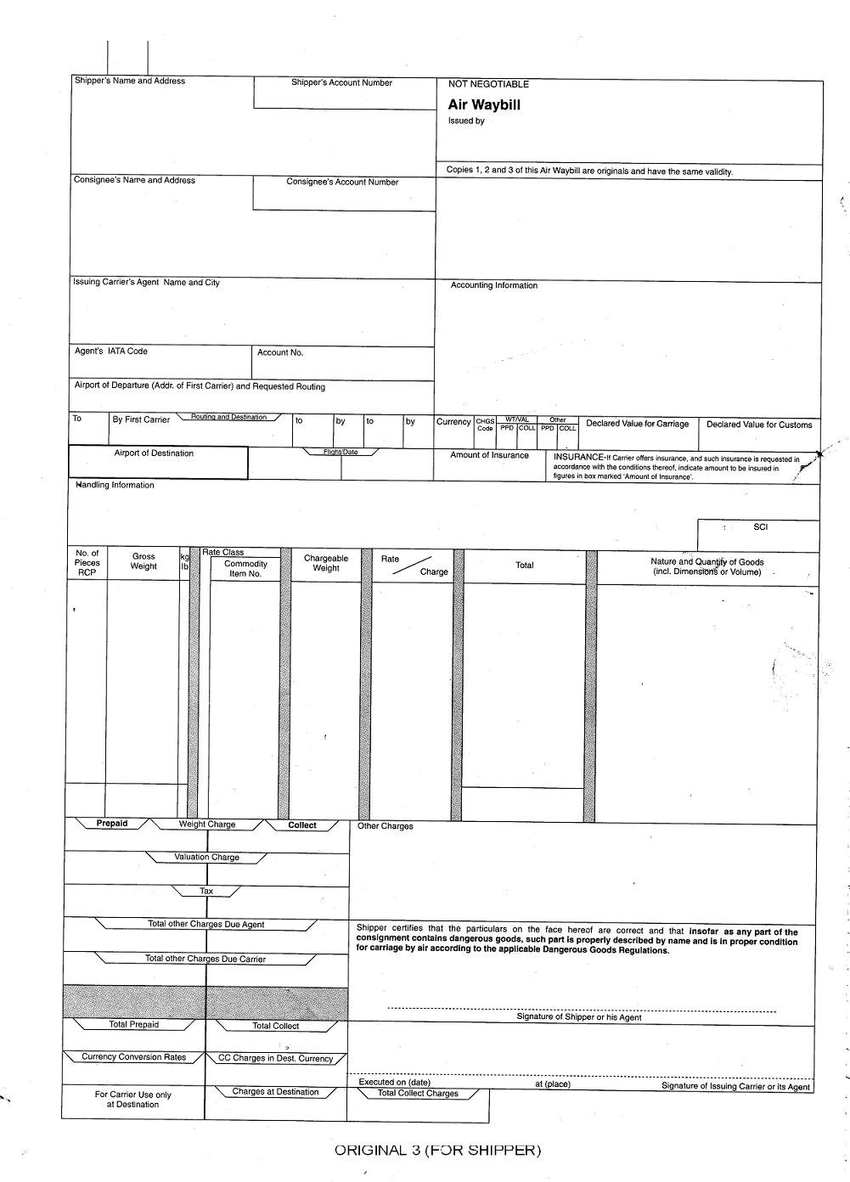
043 -

DRAGONAIR

SHANGHAI ZHONGTAI INTERNATIONAL FREIGHT FORWARDING CO., LTD.
RM201, NO.165,XINLONGZHAI,JIANGZHENXINHEVILLAGE,
PUDONG NEW AREA , SHANGHAI , CHINA
TEL:+86 21 68354211 FAX:+86 21 68354200

SAME AS CONSIGNEE

